| **Test Name** | | All service charges are reported as 0.00 when checking out. | | | |
| --- | --- | --- | --- | --- | --- |
| **Use Case Tested:** | | Check Out | | | |
| **Test Description:** | | This test script tests the known bug in the Check Out use case of Hotel Management System. This test is performed to check whether reported bug related to service charge being reported as 0.00 when checking out is present in the system. | | | |
| **Pre-conditions** | | The Hotel Management System application must be running, and the user must proceed book room, check in, record service before executing the check-out use case. | | | |
| **Post-conditions** | | User can pay the service charge using either master or visa card or cancel check out. | | | |
| **Notes:** | | As described in Pre-condition, user must follow book room, check in and record service before checking out use case. So, test data table will show all the values that was provided to replicate the error. | | | |
| **Result (Pass/Fail/Warning/Incomplete)** | | Fail, the bug was replicated during test. | | | |
|  | **TEST STEP** | | **EXPECTED TEST RESULTS** | P | F |
|  | User choose Book a Room from menu and create a booking. | | Room is booked for user with information in test table. | P |  |
|  | User choose Check in a Room from menu and check in. | | User was able to check in to the room. | P |  |
|  | User choose Register service and add Restaurant and Room Service of 300 and 200 cost respectively. | | Charges were shown to be added with visual text. | P |  |
|  | User choose Check out and continue to pay service charge and check out. | | All the cost incur during the stay was presented and user was able to check out successfully. |  | F |
| 4.1 | User choose Check out from menu | | Prompt to enter room number. | P |  |
| 4.2 | Enter room number | | Display final invoice and prompt to accept the charges |  | F |
| 4.3 | Accept charges | | Prompt to enter credit card type | P |  |

|  |  |  |  |  |
| --- | --- | --- | --- | --- |
|  | **Test Data Table** | | | |
| **Use case** |  | **1** | **2** | **3** |
| 1. Book room | Main Menu | B | B | B |
| Enter phone number | 123 | 321 | 111 |
| Enter guest name | Bikram | Romeo | Chitra |
| Enter guest address | 12 Home | 12 Hotel | 21 Home |
| Enter room type selection | D | S | D |
| Enter number of occupants | 2 | 1 | 2 |
| Arrival Day: Enter day(dd) | 26 | 26 | 26 |
| Enter month (mm) | 09 | 09 | 09 |
| Enter year () | 2018 | 2018 | 2018 |
| Enter length of stay | 2 | 1 | 2 |
| Enter credit card type selection | M | V | V |
| Enter credit card number | 1 | 2 | 1 |
| Hit <enter> to continue | 1 | 2 | 1 |
| 1. Check in | Main Menu | C | C | C |
| Enter confirmation number: | 2682018201 | 2682018101 | 2682018201 |
| Confirm check-n? (Y/N) | Y | Y | Y |
| Hit <enter> to continue | ENTER< | ENTER< | ENTER< |
| 1. Record service | Main Menu | R | R | R |
| Enter Room Id: | 201 | 101 | 201 |
| Enter service type | R | B | R |
| Enter cost: | 300 | 200 | 200 |
| Hit <enter> to continue | ENTER< | ENTER< | ENTER< |
| 1. Record service | Main Menu | R | -------- | R |
| Enter Room Id: | 201 | ------- | 201 |
| Enter service type | S | ------ | B |
| Enter cost: | 300 | ----- | 200 |
| Hit <enter> to continue | ENTER< | ----- | ENTER< |
| 1. Check out | Main Menu | D | D | D |
| Enter room number | 201 | 101 | 201 |
| Accept charges(Y/N) | Y | Y | Y |
| Enter credit card type selection | M | V | V |
| Enter credit card number: | 1 | 2 | 1 |
| Enter CCV | 1 | 2 | 1 |
| Hit <enter> to continue | ENTER< | ENTER< | ENTER< |

# Screenshot of Bugs.

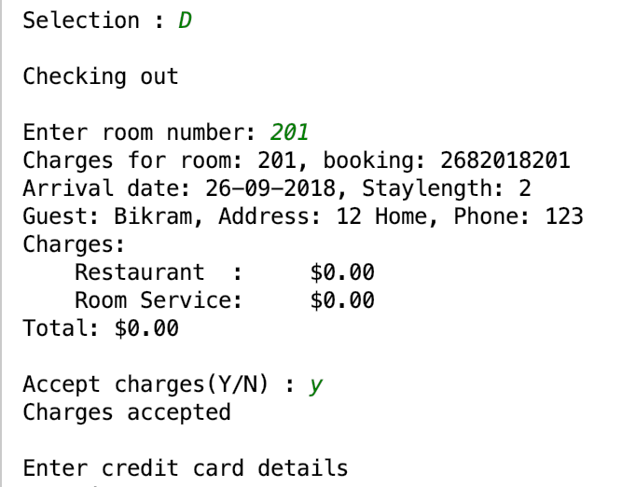

*Figure 1: Test data 1 output showing bug.*

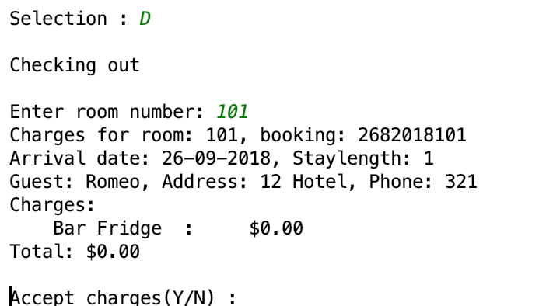

*Figure 2: Test data 2 output showing bug.*

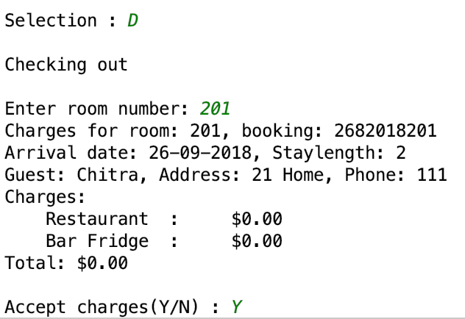

*Figure 3: Test data 3 output showing bug.*